horizontal line

**Name & Department**

Mark Forster

Sales Department (New York)

mark.forster@apple.com

One-on-One Template Form: Satisfaction

**Date: 5th September 20XX**

# SURVEY QUESTIONS: SATISFACTION

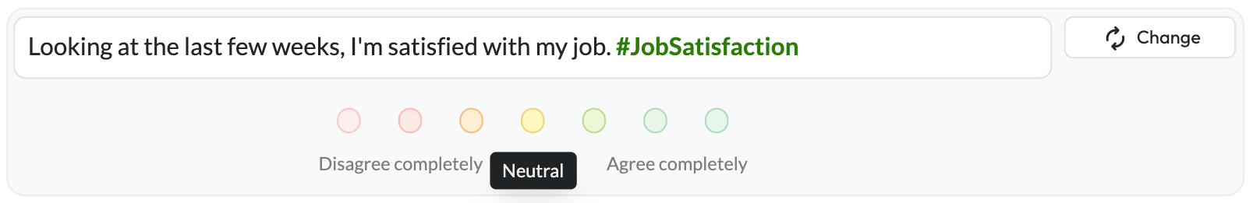

* **How much do you agree with the statement above and why?**

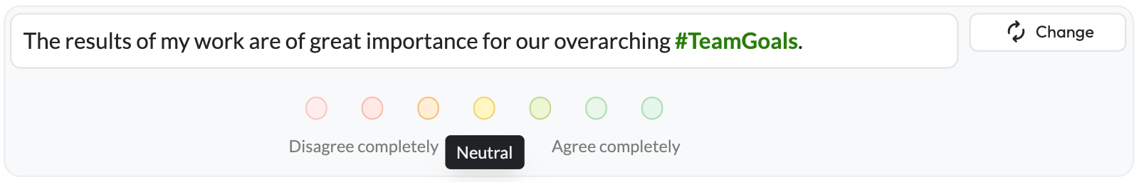

* **How much do you agree with the statement above and why?**

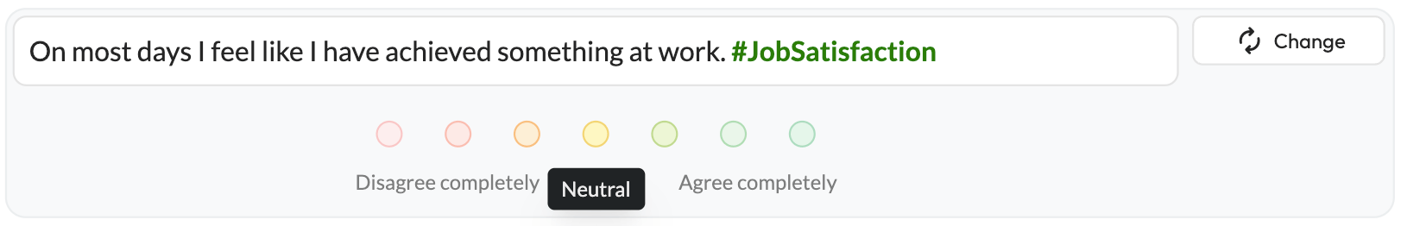

* **How much do you agree with the statement above and why?**

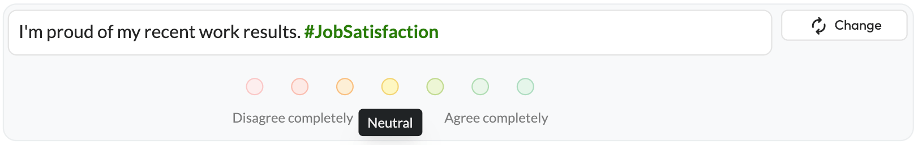

* **How much do you agree with the statement above and why?**

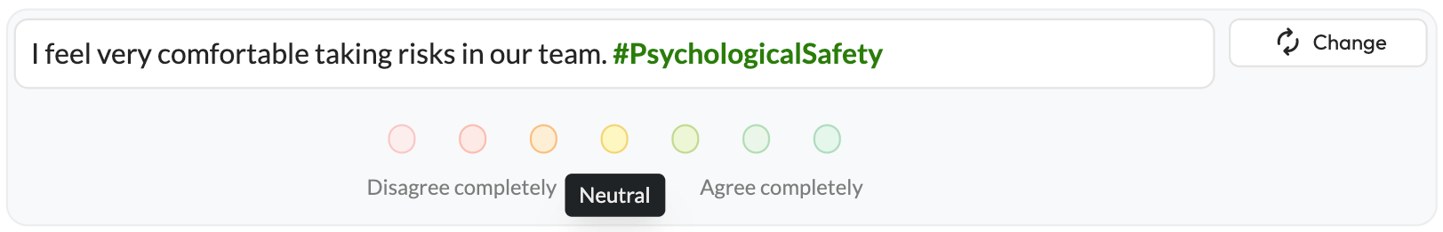

* **How much do you agree with the statement above and why?**

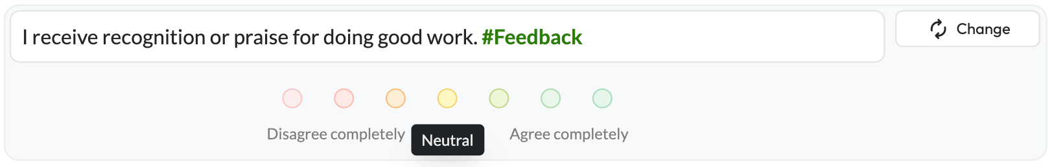

* **How much do you agree with the statement above and why?**

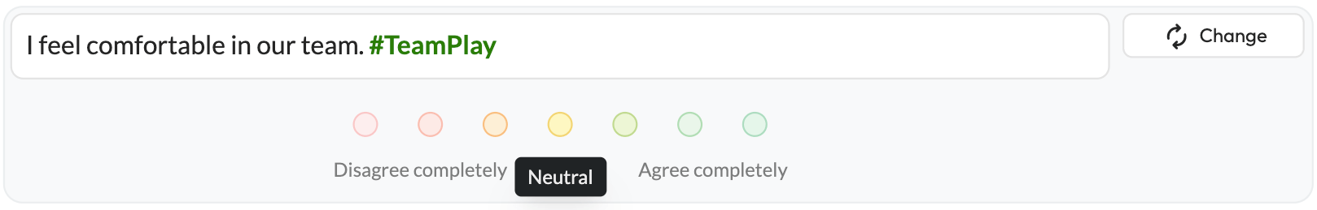

* **How much do you agree with the statement above and why?**

## CLOSING

* **How did you like today’s One-on-One including the format?**
* **How often would you like to review these topics?**
* **Do you have any further questions or concerns?**