horizontal line

**Name & Department**

Mark Forster

Sales Department (New York)

mark.forster@apple.com

Date: 5th September 20XX

One-on-One Template Form:   
 **Personal Development**

## OPEN AN INTERACTIVE TEMPLATE?

[Use this link](https://my.echometerapp.com/account/signup?mode=ooo) to open this template in the [Echometer](https://echometerapp.com/) 1:1 Meeting Tool - and get an automated history to identify development trends.

# 

# 

# 

# 

# 

# 

# SURVEY QUESTIONS: PERSONAL DEVELOPMENT

* **How much do you agree with the statement above and why?**

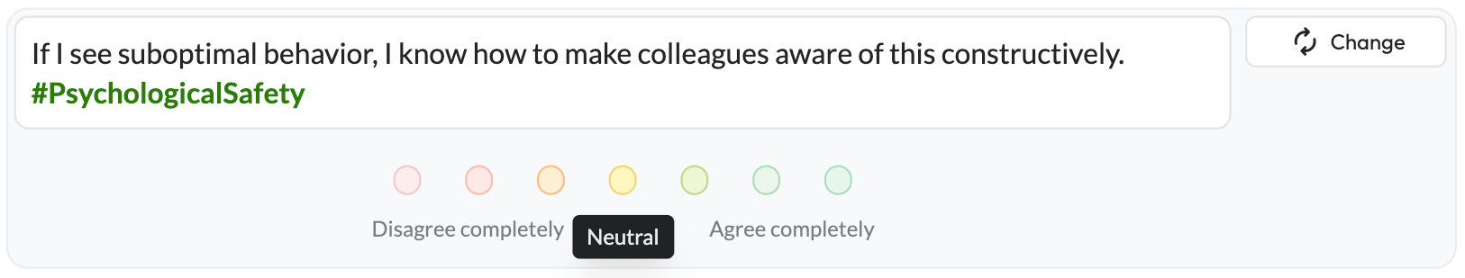

* **How much do you agree with the statement above and why?**

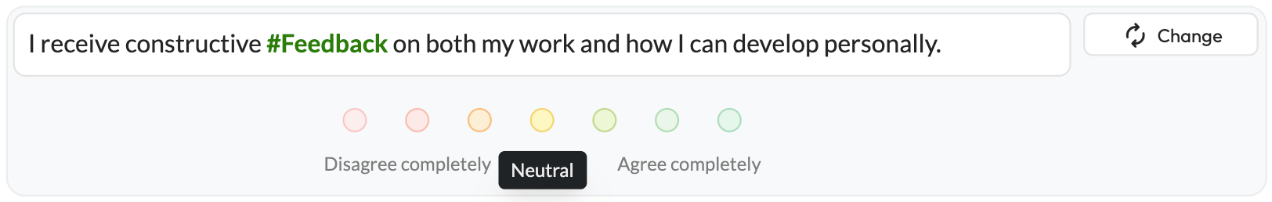

* **How much do you agree with the statement above and why?**

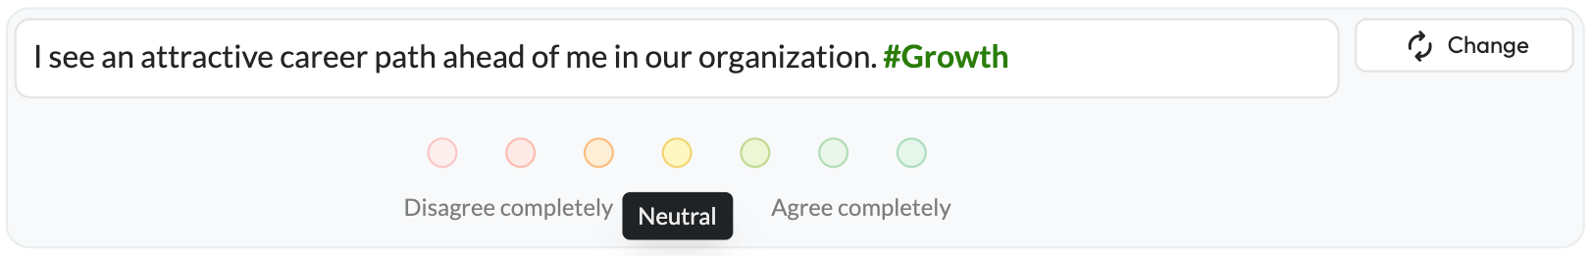

* **How much do you agree with the statement above and why?**

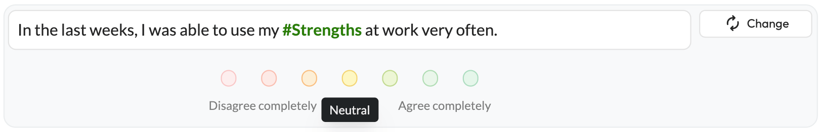

* **How much do you agree with the statement above and why?**

## 

## 

## CLOSING

* **How did you like today’s One-on-One including the format?**
* **How often would you like to review these topics?**
* **Do you have any further questions or concerns?**